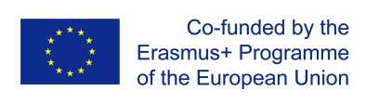
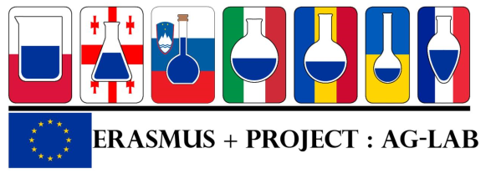

Project “Improving skills in laboratory practice for agrо-food specialists in eastern Europe» (Ag-Lab)
EU Program Erasmus +, project KA2 n° 586383-EPP-1-2017-1-SI-EPPKA2-CBHE-JP (2017-2978/001-001)
Minute of the Steering committee on-line meeting
24 February 2021, 9.00 – 12.00 (Brussels time)

Participants:
Marija Klopcic, project coordinator, UL; Dario Compagnone, UniTe; Katarzyna Kosek-Paszkowska, WUELS; Krzysztof Kafarski, WUELS; Corinne Stewart, ISLE; Nidal Shaban, ISLE; Ludmila Stepura, SMC HPHE; Olga
Getya, Natalya Gryshchenko, NUBiP; Igor Vereshchagin, SNAU; Marian Simonov, LNUVMBT; Oleksandr Bonkovski, BNAU; Mykhaylo Rublenko, BNAU; Olga Titlova, ONAFT; Anna Kievska, SRILDVSE; Nino Inasaridze, TSU; Tamar Inasaridze, CIU; Ana Gulbani, LMA; Larisa Caisin, SAUM; Elena Scripnic. SAUM; Ludmila Fedotova, CSU, Tatiana Iacimova, CRDV.
Moderator: Marija Klopcic, UL, project coordinator
Objective: Summarizing of the work done during the period October 2020 – March 2021; planning of the work for the period March 2021 – October 2021.
Topic 1: Project activities progress report for the period October 2020 – February 2021 (number of graduated, studying and recruited students at the course of Laboratory practice, common actions universities – laboratories, manual translation) – all partners under the moderation by Marija Klopčič, UL, Project coordinator
Every UA, MD and GE partner presented a short report of the activities performed during the period October 2020 – February 2021. The reports were done according to the model provided previous to the meeting by the coordinator.

Tamar Inasaridze, CIU: Number of students graduated from the course - 4 students conferred Master’s degree in Agricultural Sciences. Number of students recruited this year - 23 (first year of study), number of students studying on the program - 10 (second year of study). The common classes together with laboratories were postponed, date & topic will be defined. Practical classes - training hosted by State Laboratory is planned for Spring Semester, 2021. Reaccreditation of the Program in Georgian viticulture and oenology successfully done in August, 2020. Qualification to be awarded - Master of viticulture and oenology. The following courses adopted under the Ag-Lab project successfully delivered within the Master’s program: “Wine Chemistry”, “Wine industry safety basics”, “Microbiological control of wine production”. Georgian partners: TSU and CIU planned to start webinars together with laboratories.
Tamar said that TSU and CIU suggest to decrease the funds for travel and allocated some funds to staff costs to organize online activities and proposed to discuss this issue.
Nino Inasaridze, TSU: number of students graduated – 2 students, number of students recruited – 3 students, expected to recruit at least 5 students for the 2021/2022. On-line training “Food Contaminants and Residual Control of at Lab” has been held with the participants of Lab staff members for Master students. Has been held the practical classes - as part of the course Lab 2 training hosted by State Laboratory using liquid chromatography and PCR methods. (Semester 1, 2020). We plan to organize the practical classes - as part of the Lab 1 training hosted by State Laboratory (Spring Semester 2, 2021) and webinar joint together with CIU, SLA – date/topic to be defined. Ag-Lab Manual translation from English to Georgian is completed, final editing is on-going. Re-accreditation of Master Program in Applied Biosciences - on-going
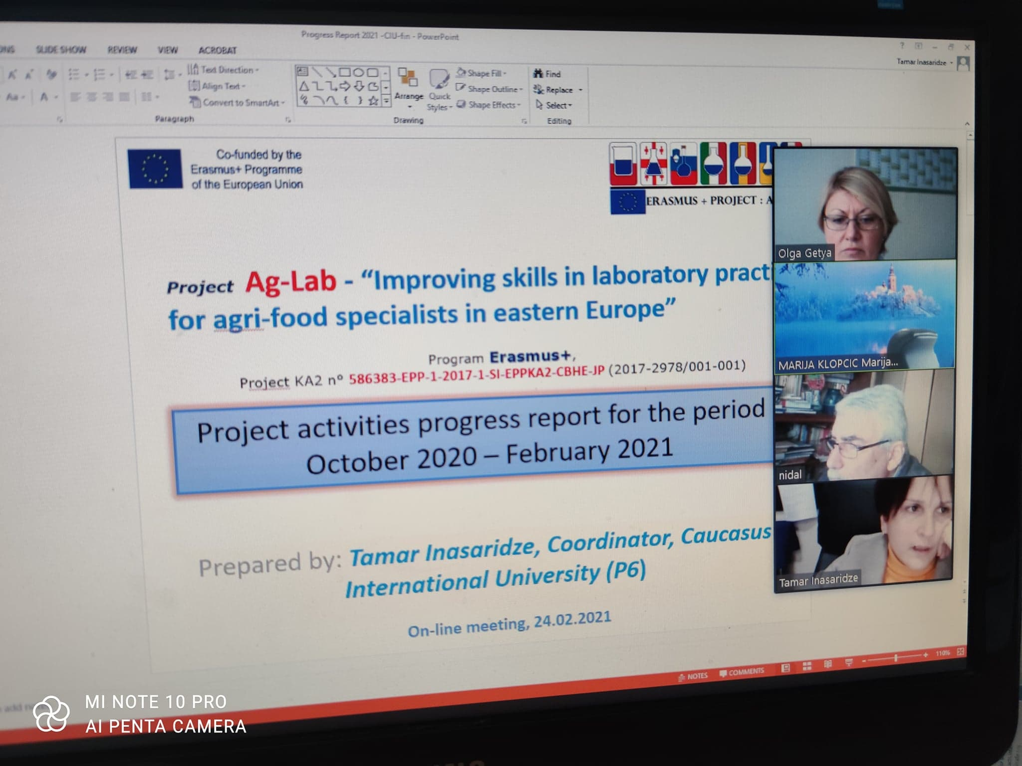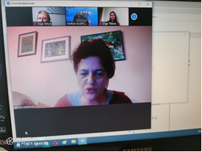
The Moldavian partners have presented the reports about their acivity:
SAUM: Number of graduated students: Veterinary Medicine study programe-49; Management in animal husbandry and beekeeping-Not, yet, will have next year. Number of studying students: Veterinary Medicine study program- 52; Management in animal husbandry and beekeeping-8. Number of recruited students: Veterinary Medicine study program- 46; Management in animal husbandry and beekeeping-8.
Tatiana Iachimova from RCVM as the representative of partner organization is organizing permanent on-line trainings for students from SAUM at the Centre. Due to that fact that the teaching is done on line, the classes are on line and there is not the possibility to meet in laboratories with large groups. Common classes are planned together with CRDV Laboratory and trainings will be organized as soon as there will be possible. The manual was translated from English into Romanian language.
Comrat State University: Number of graduated students: Agroecology-10; Number of studying students: Management in agriculture-10. Number of students recruited: Management in agriculture-12. Number of students graduated from the course – 12. There no any common classes
carried out together with laboratories.
Number of students continuing their training – 22;
Number of students recruited this year – 12;
Common classes planned together with laboratories - 5.

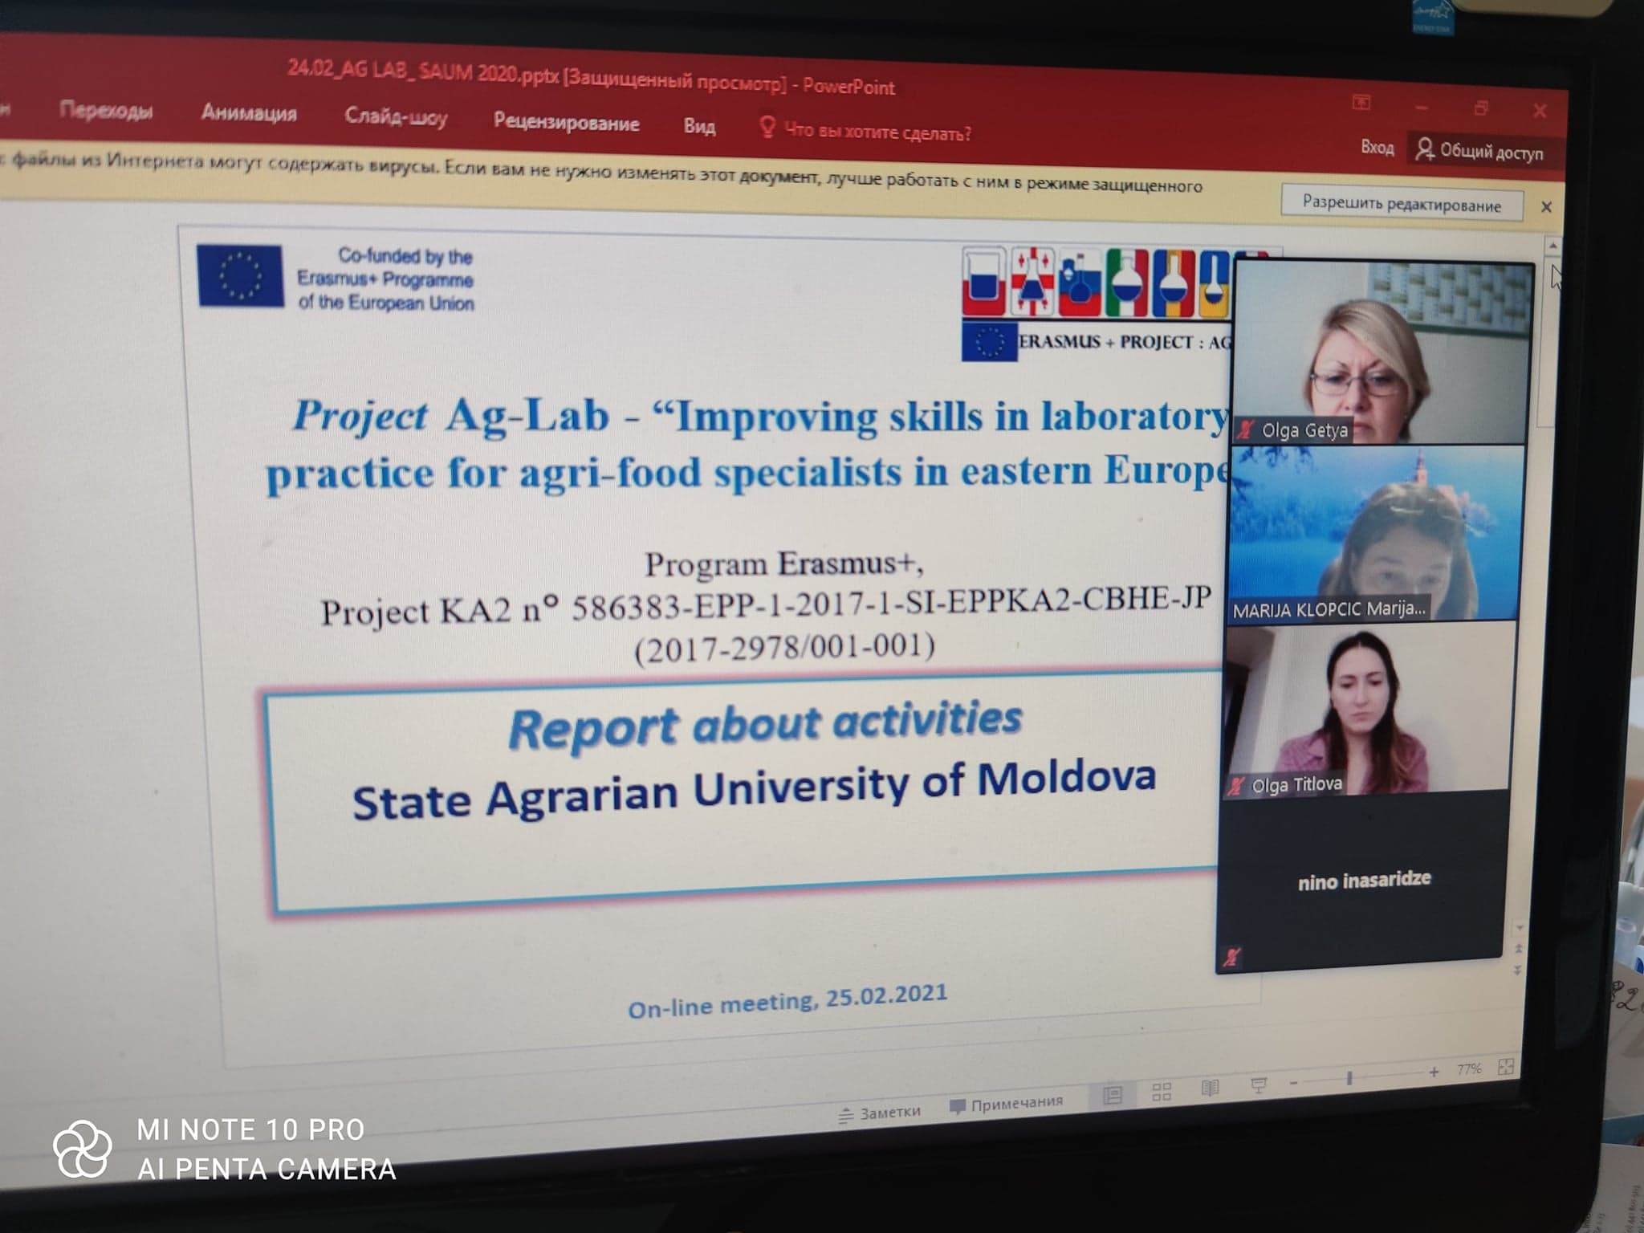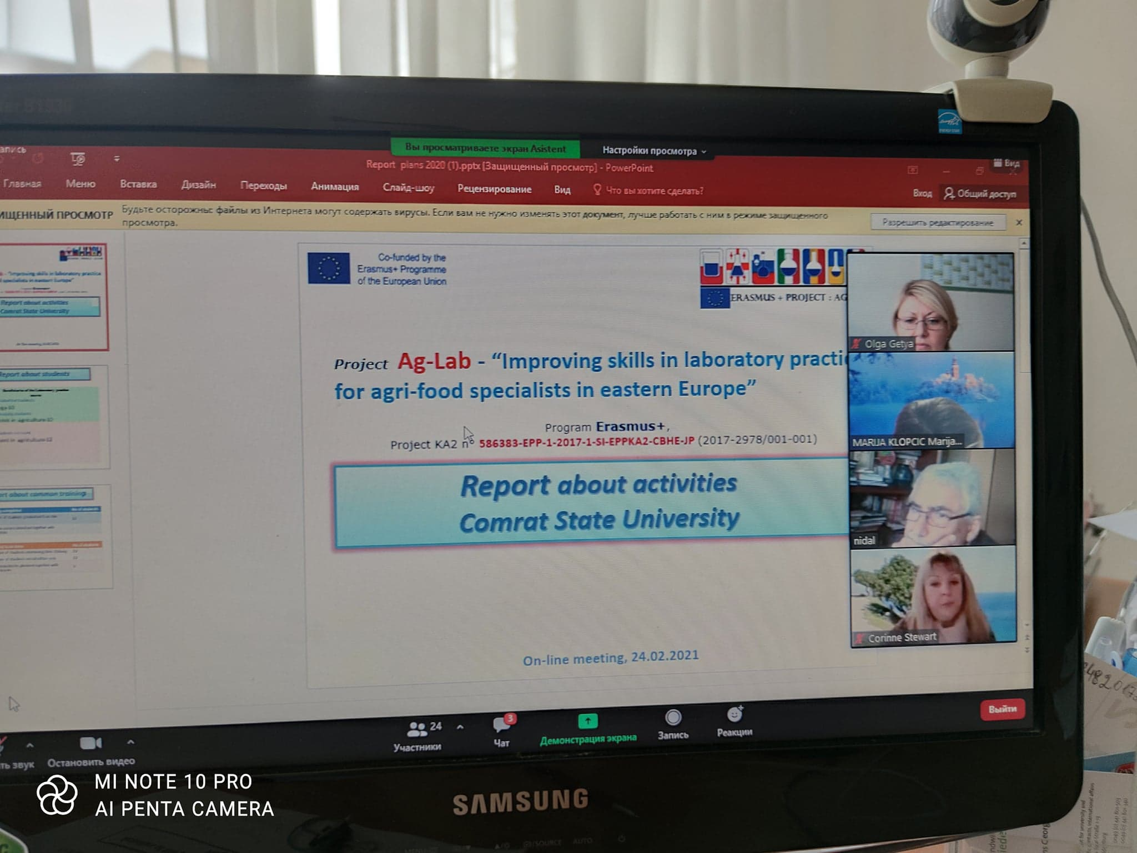
Olga Titlova, ONAFT: Number of students graduated from the course: 7 (winter 2019) 15 (winter 2020). Number of students recruited this year – 4, number of students left after 1st semester – 1. Common classes planned together with laboratories - Summer 2021. Among the problematic questions Olga marked the students mobility in these conditions and staff travels.
Natalia Grushchenko, NUBiP of Ukraine: Number of students graduated from the course – 4, common classes carried out together with laboratories - 4 (8 weeks). Number of students continuing their training -4, number of students recruited this year – 4, Common classes planned together with laboratories - 4 (8 weeks). Chapter 6. "Genetic analysis" for the Manuel " Laboratory practice" is written and translated. Moodle Courses were confirmed and placed at the platform: “Application of ICAR requirements in animal husbandry”, “Organization of laboratory work”, “Modern methods and devices of laboratory research”.
Ihor Vereshchagin, SNAU: - The number of graduates’ students there -14; The number of students who found a job after graduation is a little over 75 percent. The promotional video about the PCR laboratory, created in frame of the Ag-Lab project were prepared. It’s possible to find them here: https://www.youtube.com/watch?v=qz9z9-SCReA; https://www.youtube.com/watch?v=-YiIpHRDTwk; https://www.youtube.com/watch?v=e6Wd8Eq2TGo
Now the online trainings of the city laboratories with Sumy university were organized. They hope to have the off-line events in April and June 2021.
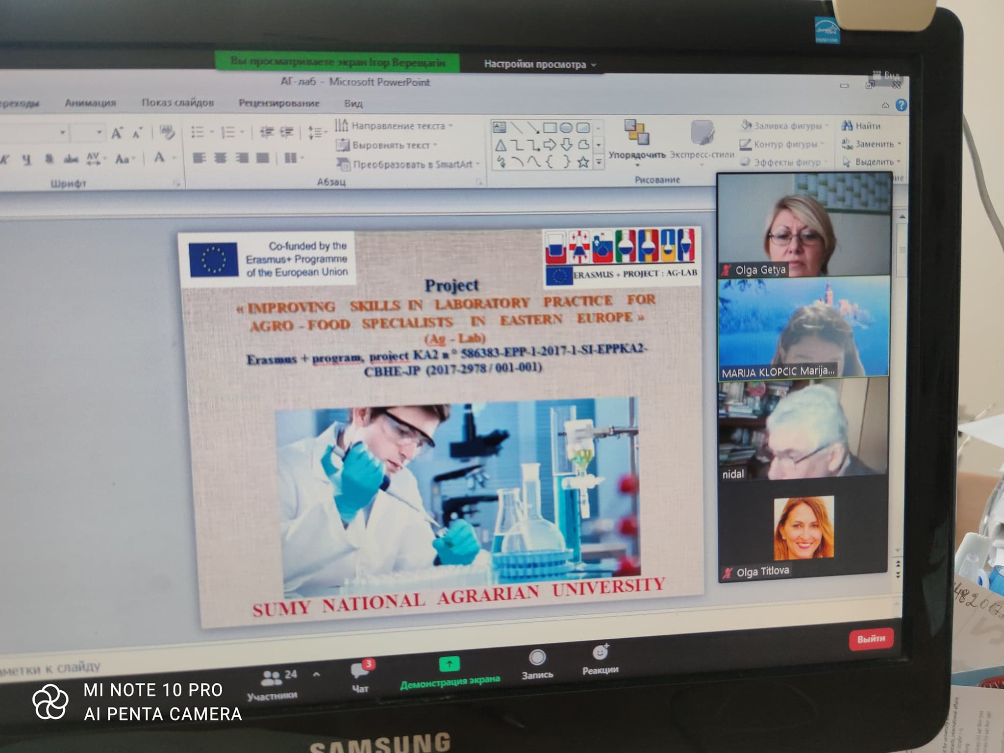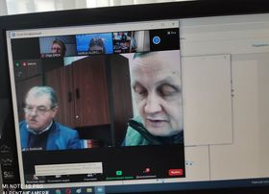

Mykhaylo Rublenko, BNAU: the first pilot group (2018) - 10 students, they graduated in 2020; in accordance with the requirements of European accreditation, the curriculum was optimized and selected as a separate elective course (7 ECTS, 2 semesters) on a competitive basis, which was recruited in 2020 and graduated in 2021 (10 students). From the graduates of 2020 and 2021, 1 person entered graduate schoolб 14 people work in diagnostic laboratories of various forms of ownership. In September 2021, a new group of 10 students will be recruited. The equipped laboratory of enzyme-linked immunosorbent assay is supplemented by a bacteriological laboratory, fully involved in the educational process. This laboratory is used for studying discipline "Laboratory Diagnostics"; The state laboratories of veterinary medicine (Kyiv, Bila Tserkva) and the laboratories of the State Research Institute for Laboratory Diagnostics and Veterinary Sanitary Examination are involved in the educational process.
Marian Simonov, LNUVMBT: Currently there are 10 students who study “Laboratory practice”.
In 2020 -7 students graduated, in 2019, 7 students graduated. An educational program "Veterinary laboratory diagnostics" is prepared for the second master's course( 211), “Veterinary medicine”.

Marija Klopcic, project coordinator, UL has presented the Project extension and new work plan for the period February 2021.
Olga Getya, SMC HPHE, has presented the formalities, related to the official recognition of the training courses in the framework of the project and presented work, that was done by SMC HPHE: Translation and edition of the manual “Laboratory practice” from English to Ukrainian language; re-registration of the project due to its continuation; creation of the film about the use by universities of equipment purchased in frame of the project and presentation of this film at the international ERASMUS Days.
Ludmila Stepura, SMC HPHE presented the plan of the activity until the end of Ag-Lab project (till 15 October, 2022). Among them are: Revising of the elaborated training courses (March-May 2021); Informing stakeholders about the content of the updated educational programmes for acting laboratory staff; Training session for teachers and laboratories staff from UA, GE and MD at the University of Ljubljana (April – May 2021 (according to the situation); Three study visits to EU universities (Since June 2021 (according to the situation); The experts missions from EU to MD, UA and GE (according to the situation); Finalisation of the translation and publishing of the Manual devoted to laboratory practice in Ukrainian, Georgian and Romanian (By April 2021); Permanent completion and improvement of MOODLE platform; Providing materials : articles, new relevant information for Web-portal; Students mobility between UA, GE and MD(according to the situation); ensuring cooperation of laboratory staff with university teachers; work on External project publications; Relaunching the development of the Advisory coalition board to sustain the results of the Ag-Lab project after its lifetime and to finalize the adoption the Sustainability strategy.
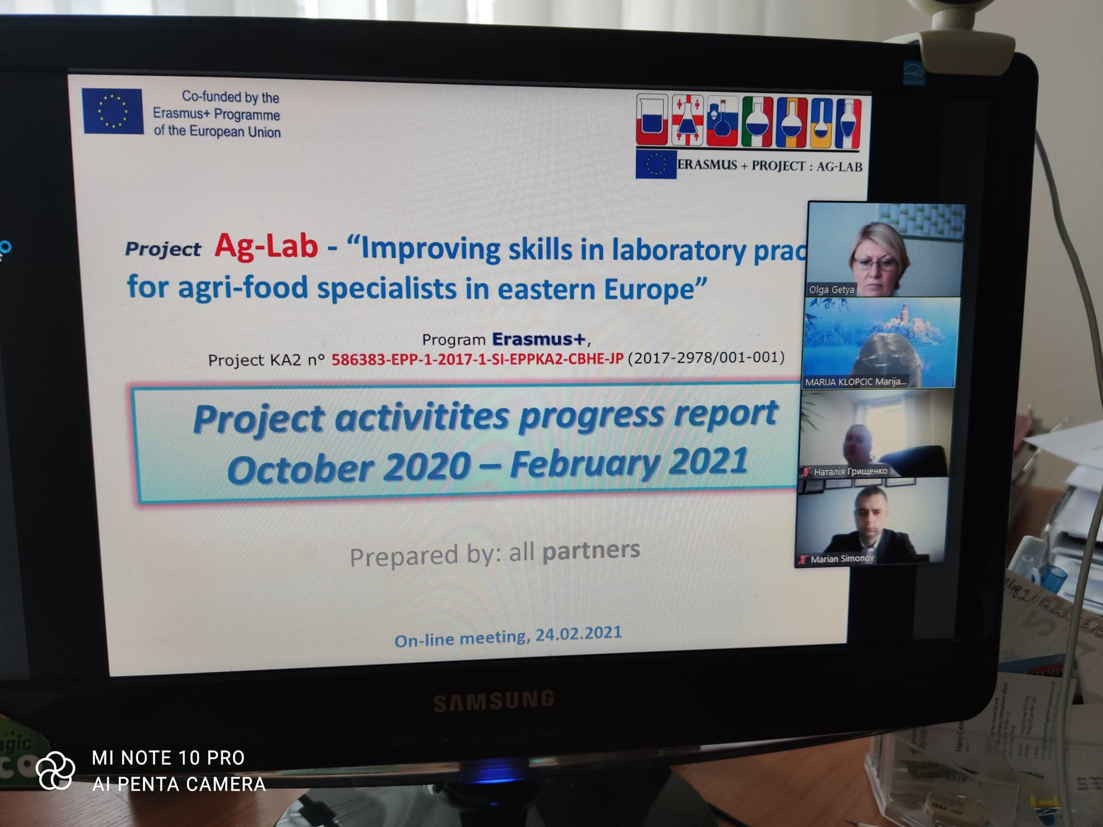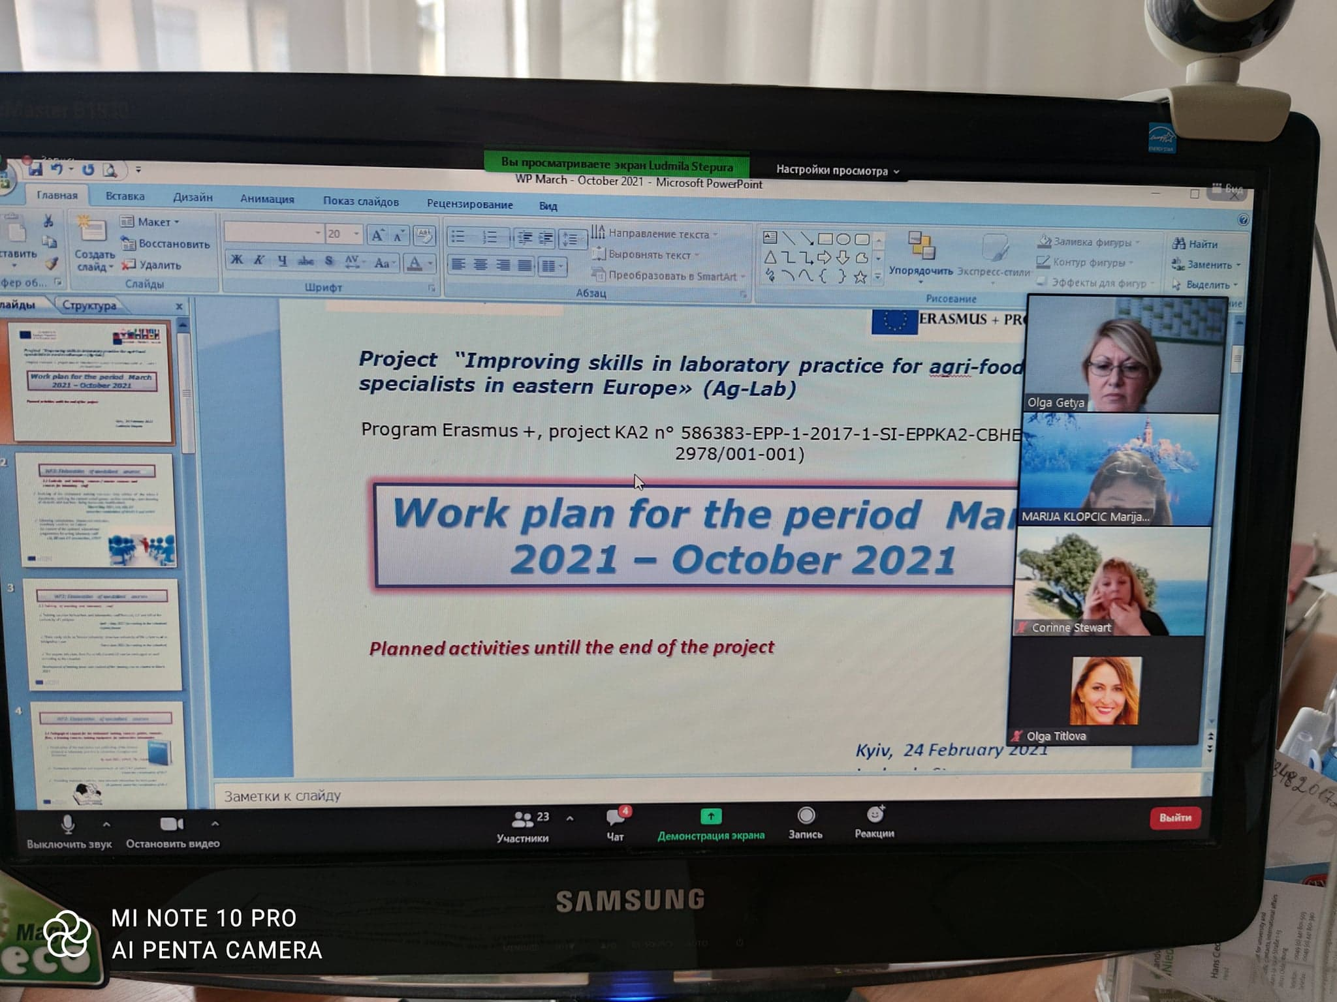

Corinne Stewart, ISLE has presented the MOODLE platform – its current state and further activities. She told how many training lectures were given and whether they met the requirements. Сorinne Stewart made the analysis of other dissemination activity.
Krzysztof Kafarski, WUELS made presentation about Quality insurance during the quarantine period. He has marked the main problems of project’s realization during pandemic: сommunication flow among partners is disrupted, postponement of trainings and mobility, on-line meetings cannot replace the real face-to-face meetings, delay of the project activities and uncertainty about the future COVID-19 restrictions. An analysis of the consortium members' views on how the situation could be improved was made.
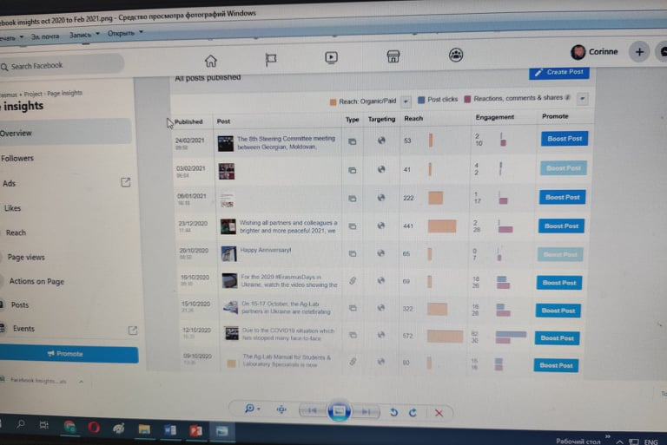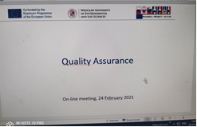
At the end of the meeting, the project coordinator Marija Klopcic, UL spoke about the perspectives for the mobilities restoring and organization of the next steering committee meeting.
All members of the meeting took part in a discussion on how to set up the project activity during the pandemic and how to use the funds if we are not able to implement all the planned mobility. Most partners agreed that every opportunity would have to be taken if quarantine was relaxed. There was also a proposal to organize a mixed form of mobility - countries with a good situation can travel, and countries with a bad one - join the events online.
A proposal was made from Polish partners to plan a study visit to Wroclaw in June (In case of a good situation). The final steering committee was scheduled for April - May (if the pandemic situation allows).
Nino Inasaridze from TSU proposed to spend the money planned for mobility on staff salary, but most of partners were against this proposal. So, it was decided to discuss thus question later.



